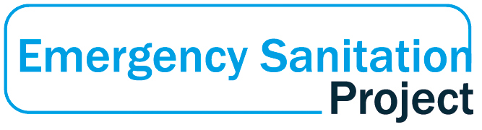
WASTE DISPOSAL IN EMERGENCIES WORKSHOP
July 25 – 28, 2017

Background
The Emergency Sanitation Project (ESP) is a consortium of humanitarian agencies and other partners dedicated to researching new technology and methodology for improving the ability of humanitarian organizations to provide sanitation in emergency response. Phase 1 of the ESP, funded by USAID, explored a number of new technologies for sanitation in emergencies. One of the research streams looked at sludge disposal methodologies. This included:
· Basic research into the effects of various substances on faecal sludge
· Heat treatment
· Anaerobic treatment
· Vermicomposting
· Bio additives
Results are not complete for any of the above but all showed promise for enabling safe disposal of human waste. Two elements of sludge disposal in emergencies have not been explored. First, the methods have not been trialed in combination. It is possible that higher effluent quality and improved system efficiency can be obtained by running treatment methods in series and parallel. Second, apart from the heat treatment and anaerobic digester, most of the sludge treatment tests were proof of concept rather than operational trials of ready to use equipment. The sludge treatment methods identified in Phase 1 require more research, but that is true for most technology. The need for rendering human waste safe is both enormous and urgent.

Most wastewater treatment plants employ an array of treatment technologies in order to ensure safe treatment for a variety of sludge characteristics. It is unlikely that any one technology would be sufficient for a task as difficult as treating human waste, particularly in an emergency context. Apart from one of the tested bio additives (which has its own limitations), none of the methods trialed or considered in Phase 1 is even theoretically capable of producing completely safe or nuisance free effluent. Combination trials would determine whether using more than one method in series would make the disposal process more efficient or the final effluent safer and easier to release into the environment. Furthermore, as all methods have different detention times, resource requirements and efficiencies with sludge of different characteristics, a matrix arrangement would create a sludge treatment facility that is flexible in a range of contexts and conditions.

Phase 2 of the sludge treatment research stream would turn sludge treatment methods into deployable kits and then test how the different methods complement each other.

Progress to date

A 3 day workshop was held at the British Red Cross Warehouse in Bulwick, UK July 25-27, 2017 in order to

- Become more familiar with the operational requirements of new sanitation technology
- Resolve issues with assembly prior to field deployment
- Develop preliminary protocol for combined waste treatment using technical specifications of the equipment
- Identify personnel for the field deployment trial.

The opening presentation can be found here: https://docs.google.com/presentation/d/1wZLa9ElQtVJnvr_z9-2DAtiXLxk4qv-S1StnmLjEVxc/edit#slide=id.p49

The workshop included assembly and operation of units and desktop exercises to detail a more complete design for a treatment facility. No human waste was involved at this stage due both to the difficulty of sourcing this material and in order to ensure units are easy to transport to the location of field trial.

The workshop was attended by nearly 20 participants, primarily from the Red Cross Red Crescent Movement. Participants had a wide range of experience and expertise, including sanitation in emergency response and wastewater treatment process engineering.

Day one focussed on introducing the ESP to participants and a detailed look at the equipment that has been purchased to date. Participants broke into four groups and assembled a storage tank, an anaerobic digester, a diaphragm pump and a heat treatment unit. Results are summarized below. Specific feedback will be shared with the suppliers.

Day two largely revolved around a desktop exercise where teams proposed designs for a field waste treatment facility. The merits of each design were discussed in depth and, with additional work on Day three, eventually combined into one design. The results can be found below.

The workshop also included presentations on the Loowatt, Biocube, urine drying and Auto-Thermophilic-Aerobic-Digesters.

Planning for the next stage is underway. Final selection of field trial location is expected soon. When the design and BOQ are complete, procurement will be initiated and equipment shipped to the field site. A field trial lasting approximately 6 weeks will be carried out with faecal sludge.

Feedback on current equipment

On Day 1, participants broke into four groups and were asked to give the following feedback

- What does the technology do?
- What are its limitations?
- What is missing?

Heat Treatment Unit

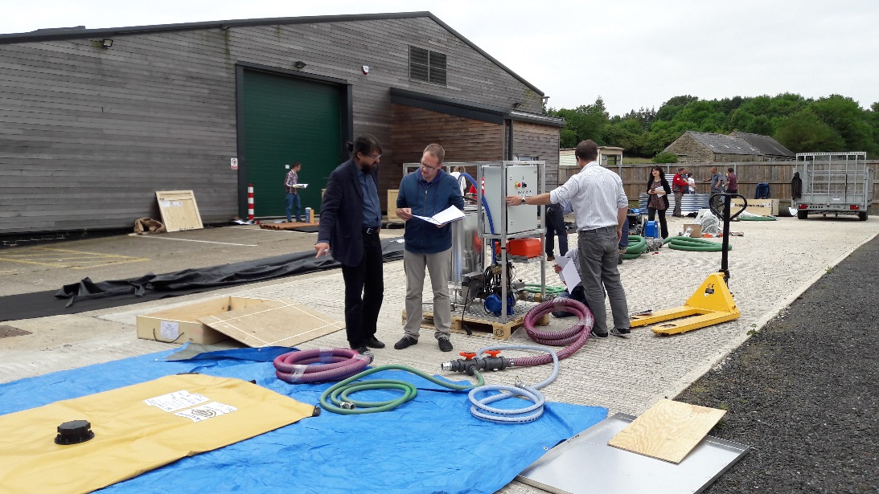

Elaboration on exactly what the unit does. At present, it states only that it heats the influent to 70 degrees centigrade for thirty minutes. That’s it!
No technical details provided on the volumes of the tank, how long a full cycle is?
Fuel filling intervals and size of generator support if direct mains supply is not available.
Limitations
Actual capacity in a working day?
Dirty power supplies mean the circuit board is vulnerable as it is complex in content.
Climate could cause issues, eg. Heat, humidity or dust. Would need a shelter to cover the system.
Screening – practical advice to keep below 1cm particles.
Viscosity of sludge the system is capable of handling.
Operation and maintenance needs to be explicit to minimise breakdowns.
Missing items
Inlet and outlet tanks – general advice on types and volumes.
Assortment of attachments and pipe fittings for different applications.
Spare parts. E.g fuel filters.
Chlorine.
Solid diagram on the control panel os the system. Schematic
Full ID on all components.
Colour code connections to make assembly simple.
Temperature and time display. Analogue?
Clean water for chlorine make up.
Antifreeze if cold environment.

Sludge storage
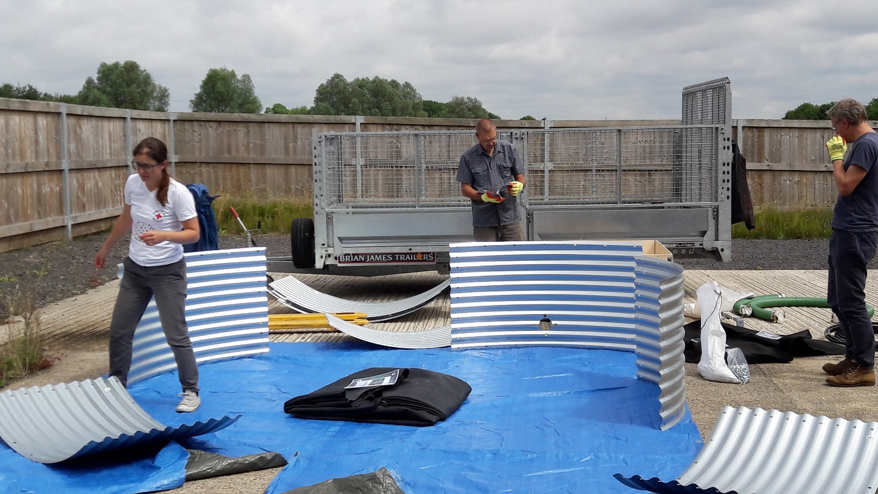
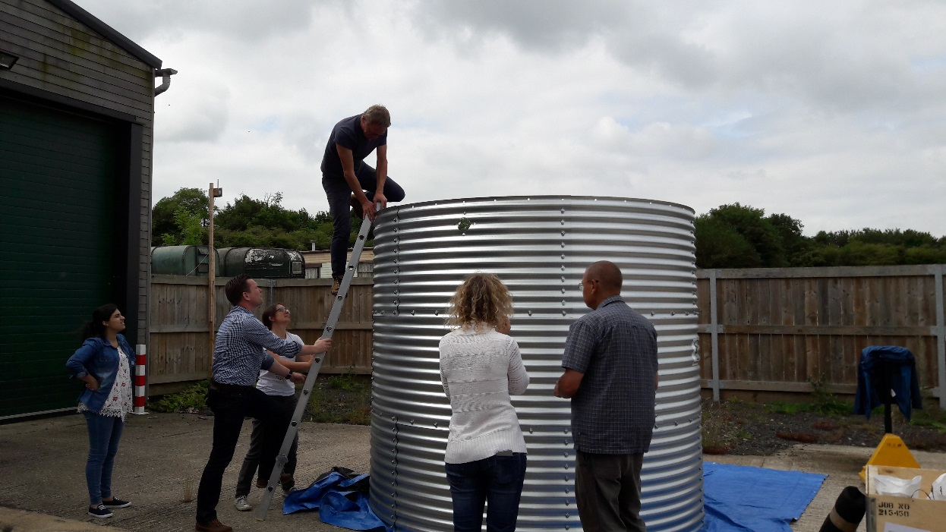

What does it do?
- Store 10m3 sewage / septage
- Transfer station
- Limitations:
- Difficult to empty after seperation of solids - retention time would be limited (daily?). Sludge build up at base needs to be avoided, needs a high turnover.
- Small volume
- Not possible to fill manually
- Carbon filter looks easy to block and potentially fragile
- High - elevated pressure sewage!
Missing?
- Coarse filter or screen at inlet (above sludge pit - manually rake off solids? or back wash?)
- Inlet for manual filling?
- Tool kit
- Suggestions for improvement:
- Increase volume - using similar Oxfam tank design
- Improve labelling on kit for ease of installtion e.g. colour handles above flange, mark orientation of flange
- Attach the carbon filter to the tank with a hose attachment to a vent on the bladder
- Make the tank lower and wider
- Some clarifications and corrections to manual (e.g. alignment of pipe holes in metal sheets under pt 5: when and how to insert bladder
- Longer pulley cord
- Improve flange - very difficult to fit to bladder due to limited space and extended screws may puncture bladder when full. Extend internal flange so easier to fix to spigot.

Pump Pelican 352 (Lombardini)

What does it do?
- It can pump 300 LPM (18m³/hr)
- It should not operate for more than 8 hours;
- It uses 1.5L/hr of diesel. The tank capacity is 2 L of diesel;
- It can lift water 7.5 meter but the suction lift should be maximum 2 or 3 meters;
- It can do 2750 rpm which give 60 stroke per minute for the diaphragm;
- Limitation
- It can take up to 36 mm diameter of solids;
- It can only lift up to 7.5 meters.
- Everyday day you need to check the level oil.
- There is only 2 L in the tank;
- Oil depends on season (i.e. in cold weather you would another kind of oil);
- In this configuration it Is not made for high altitude;
- What is missing?
- All the technical specification missing (i.e. fuel consumption, pumping volume).
- In the manual is mixed together, it say just 7.5 meter no specifying the head and suction capacity.
- Miss drawing with steps by steps instruction;
- Missing the packing list with the list of the content of the kit;
- The spare parts should be enough for at least 4 months;
- The ration fuel filter and oil air filter is not correct. There should be twice as many fuel filters.
- Service schedule was not in the manual (i.e. changing filters after how many hours);
- Only one jerry can for the fuel, there should be two (One is full while the other is being used). The jerrycan needs a nosel;
- Only one #19 spanner. You need two to change the membrane;
- The screw driver Philips cross head missing;
- The two bolts for fixing the handle are not enough long, you need two 12 cm bolts;
- It is needed to have #2 hose key;
- There is a funnel for oil, but a funnel for fuel is missing. The funnel should be with a filter to take out particles and water;
- Missing the Teflon tape to seal the treads;
- Missing working gloves;
- Extra string for starting the engine as spare part;
- Note that a metal jerrycan full of fuel is not allowed in UN flights;
- It would be nice to have a metal box for the tools and spare parts;
- It would be good to have a 20L bucket to prime the pump;
- It should be good to have 2 additional Storz B, connector with 3 inch inside tread;
- It should be good to have a service book (You need to know how much diesel use, when change the oil etc…);
- It would be good to have two different type of oils, for cold and hot weather;

Anaerobic Digester
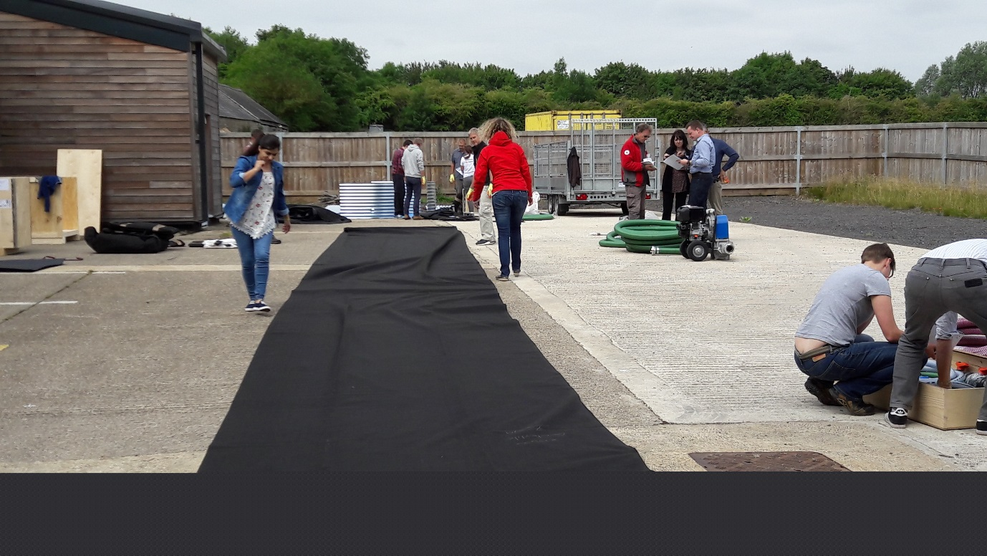

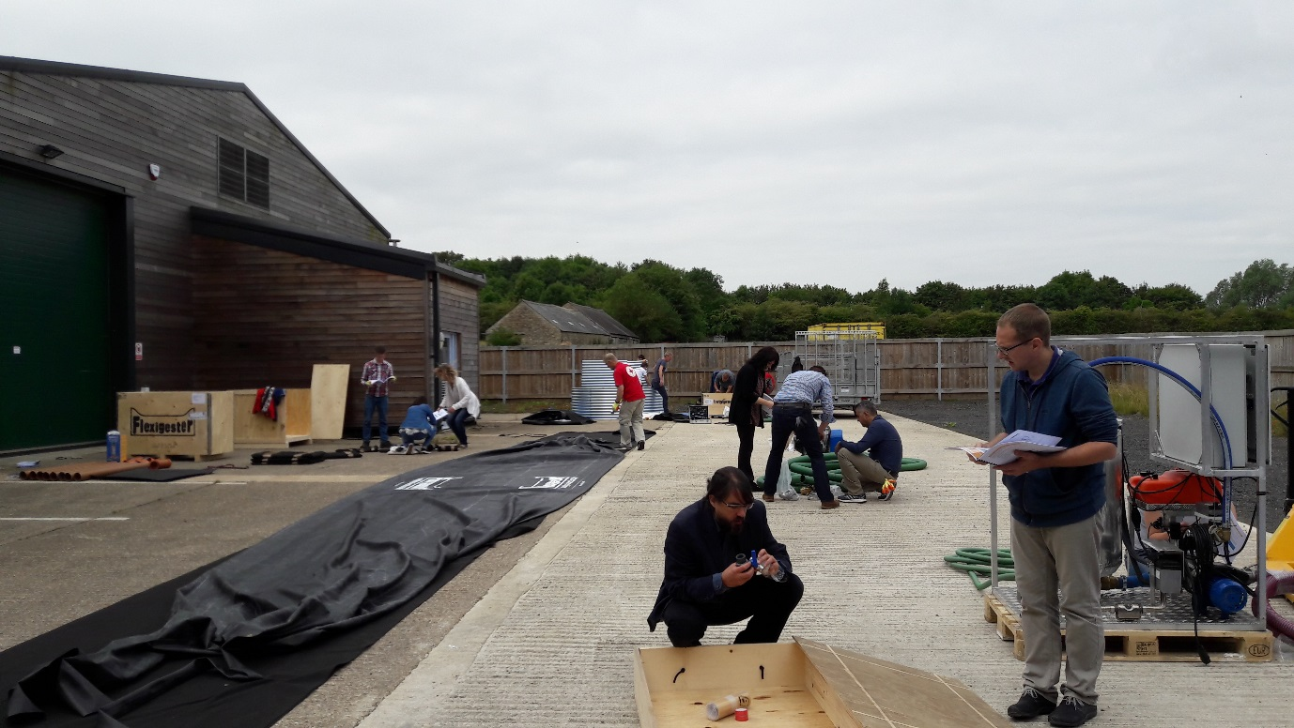

What does it do?
- Pathogen reduction – How much? Any results from field testing?
- Organic load reduction
- Biogas production – energy
- Anaerobic digestion of wastewater
- Solids degradation/stabilization
- Containment of the waste so reduction in risk from contamination

What are the limitations
Number of people to serve max ~ 250 per flexigester based on 28 days retention time 2L/ person coming from a latrine (5-13 latrines based on sphere standards)
Regular feeding and not too varied. Need steady population
Health and safety risks with biogas – No flame traps. Risk with people using biogas in a safe way.
Partial reduction in load so still need another biological treatment step afterwards
Sludge will build up over time in the system which will reduce the retention time of the system if it is mostly liquid
Limitations as to how much chemical waste you could take and liquid cleaning waste – i.e. for clinics.
Likely Not going to work in urban contexts due to huge number of people and limited space
Can go wrong and be hard to recover
How to empty the sludge or empty the tank if you need to
Operating parameters are not clear enough to someone without a technical wastewater background.
What is missing
Level of solids you can feed – No specific instructions, but manual suggests you may have dilute concentrated so this would be only a few %. Can you feed it at higher concentrations after a settlement process. What level of solids could you feed it at.
Could you run it at higher concentrations with this design or would you need to modify the design?
Only part of the solution
Need pretreatment as a minimum for screening
Settlement process before
Additional treatment afterwards (lagoons, reed beds, composting)
The intended use from the manual sounds like relatively dilute wastewater/sludge is what it was designed for. Could it be used for more concentrated solids content or would it not work with this design?
What kind of pathogen reduction can you expect with this design at different temperatures and retention times?

Design Work
Days 2 and 3 were spent in a desktop exercise refining the design for a sludge disposal facility. Three designs were presented. Apart from the idea of lagoons, which all agreed were practical but not within the scope of this workshop, the designs were very complementary and elements could be combined into one design.
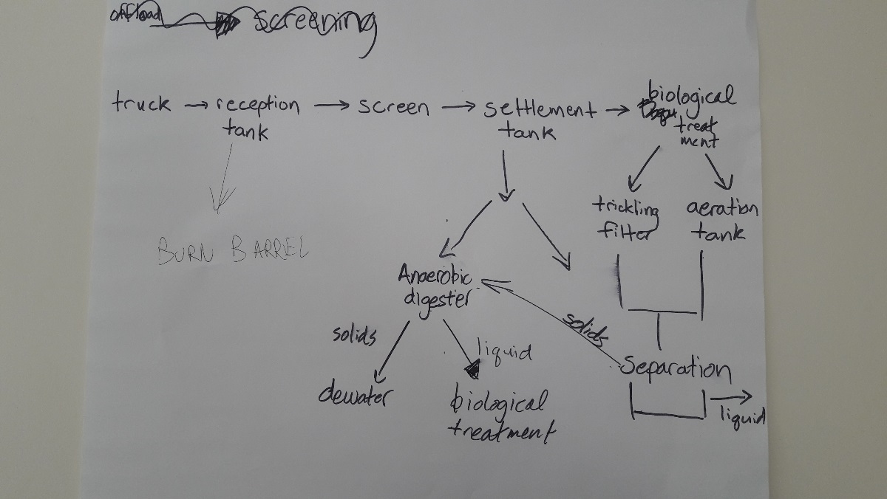

This schematic was later refined in the below.
Design for full treatment facility

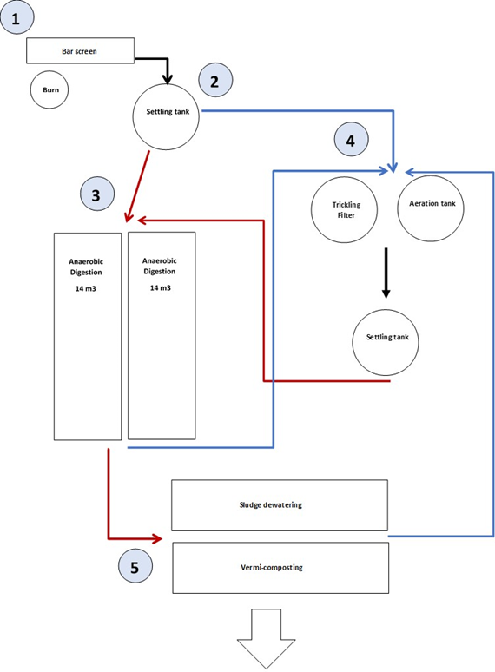

Key
Black - mixed waste
Brown - Sludge (assume less than 10% solid content)
Blue - Liquid

Components
- Bar screen. Trench with heavy duty lining. Overflow barriers. Burn barrel for raked off waste. Gravity offload from truck. Pump to next stage.
- Settling tanks. T45s. Aeration?
- Aerobic digesters. Sludge pumped to anaerobic digesters. Quantity?
- Biological treatment. Liquid pumped to T45 tanks.
- Dewatering. Initial process to use 1 m3 construction bags to dewater. Vermicomposting to be brought on line over time.

Next Steps and To Do
To do:

- Jesper to explore commercially available bar screens
- Kurt to explore aeation systems
- Improve schematic
- Complete BOQ

Work is now underway to finalize the equipment list and determine the field testing location.

Conclusions

The workshop brought together a wide range of expertise from across the Red Cross Movement, industry, and academia. It was well understood by all participants how complicated this issue is and the limits of desktop calculations in getting the equipment to function. The group believed that the challenge of sludge disposal in emergencies can be solved, but that we need to try out the concept in the field in order to get the final design right. Participants were eager to join field trials and lend their experience and expertise to the work.

