38th WEDC International Conference, Loughborough University, UK, 2015

Water, sanitation and hygiene services beyond 2015:
improving access and sustainability

Desludging of ‘difficult’ sludge with ‘easy’ equipment designs: Results of field-testing in Blantyre – Malawi

J. Spit, W. Carter, J. De Gabriele & J. Heeger, (The Netherlands)

BRIeFING PAPER

The purpose of this paper is to document the findings of recent field trials of equipment used for desludging and transportation of sludge, including in emergency settings. During a 9 month testing period in 2013 and 2014, innovative desluding equipment was used to remove over 430 m³ of “difficult faecal sludge” from over 200 household and institutional toilets – mainly unlined and lined pit latrines and a few septic tanks. After some major modifications to the equipment, the field team found that effective and efficient emptying of pit latrines under a wide range of conditions and with difficult sludge is possible, practical, and cost effective for humanitarian agencies and local governments.

Project Summary
Once a pit latrine is full, latrine owners in most places have little alternatives but to abandon their pit and dig a new one or to manually empty the latrine. Common mechanical methods for emptying of latrines in emergency and non-emergency settings have proven to be expensive and often dangerous. While some new manual techniques like the gulper and the trimmer have recently come on the market, there are currently few alternatives available in most settings from the common vacuum desludging trucks and manual emptying. The common vacuum sludge trucks do have a problem with sucking pit latrines, as the sludge is often thick and not really fluid.

As part of the Emergency Sanitation Project (ESP) and the S(P)EEDKITS project, new desluding equipment was developed and modified for use in various contexts, including humanitarian emergencies.

The field trial involved the use of desludging equipment in the following settings:
- Lined and unlined pit latrines
- Septic tanks
- Domestic and institutional toilets
- Urban and rural areas
- Pits in current use and those abandoned when full
- Pits with old sludge (10 years old) and fresh sludge (up to 2 weeks)
- Emptying with and without fluidising

The following desludging equipment was imported into Malawi and tested during 9 months of field trials:

- ROM2 costing 12.000 Euro. The ROM2 is a vacuum-operated desluding machine with an integrated high-pressure pump for fluidizing sludge and an 800L holding tank manufactured by ROM B.V. in The Netherlands (see Figure 1);
- Vacutug Mk 2 manufactured in Bangladesh costing 7000 USD. The Vacutug has a diesel-powered vacuum pump with a 500 L steel holding tank. The diesel engine also provides power for the self-propulsion (see Figure 2);
- Diaphragm sludge pump supplied by Butyl products, Great Britain. The pump is applying a Lombardini diesel engine (see Figure 3).

As neither the Vacutug nor the Diaphragm pump came with a fluidiser, a separate high pressure washer manufactured by Karcher, and 3 nozzle options were later included.

Over the 9 month testing period over 430 m³ of “difficult sludge” in over 200 household and institutional toilets – mainly unlined and lined pit latrines and a few septic tanks was emptied. “Difficult” in relation to pit latrines refers to the fact that the latrines are difficult to reach due to small, often narrow, unpaved and/or sloping roads. ‘Difficult’ pit latrines also refer to the fact that the squat holes are small and/or the squatting plates are fragile. ‘Difficult’ in relation to sludge means that the sludge is ‘thick’ meaning that it has low moisture content and/or is mixed with solid waste.

After some major modifications to the equipment, the team found that effective and efficient emptying of pit latrines under a wide range of conditions and with sometimes solid sludge is possible. We tested and modified equipment that was able to take significant amounts of sludge from pits up to 3 meters in depth in a safe, quick and cost effective manner.

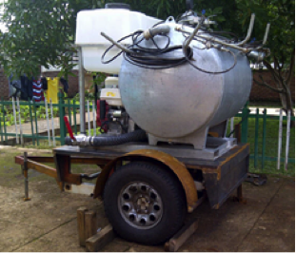 |  | 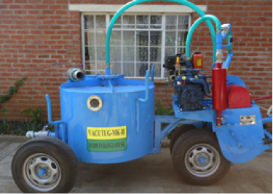
Photograph 1. ROM vacuum machine |  | Photograph 2. Vacutug

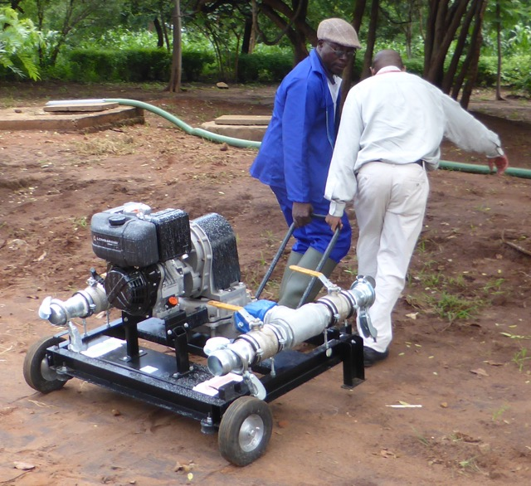
Photograph 3. Diaphragm sludge pump

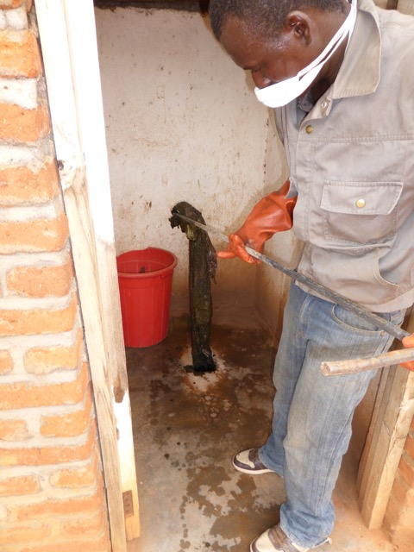
Photograph 4. Fishing process after fluidization

Key Results

Over 200 lined and unlined pit latrines were emptied. The team managed to take at least 800 litres of sludge from every latrine they were requested to empty. None of the latrines collapsed during the desludging debunking fears that high-pressure water would cause unlined pits to collapse. However examination of the sludge contents showed that the sludge from unlined pits contained a lot of soil, gravel and even large stones from the pit wall. It was not clear if some of this was a result of the fluidising process. The team also managed to empty several pit latrines that had been abandoned for several years due to the pits being full.

The different equipment tested had strengths and weaknesses. Vacuum based equipment was more effective but the ‘original’ equipment (developed to empty mobile toilets ‘dixies’) had to be adapted to the difficult conditions: larger diameter hoses, longer hoses, manhole to remove rubbish etc.

Contrary to popular belief, fresh sludge (as found in emergency camps) also required fluidisation and had post fluidisation total solid content of 15% in market toilets with high usage and no introduction of water into the pit due to ablutions with water.

Conclusions

Specification of equipment
As the units were ideal for different contexts with different price points, it is essential that agencies or governments considering stockpiling desludging equipment, consider the training of operators and consider mainstreaming the equipment as they have a wider application than the emergencies.

Importance of fluidising
Fluidisation of the sludge is needed to be able to remove the sludge from the pit latrine. This is done by injecting small amounts of water with high pressure with a special lance and nozzles into the sludge. . Without fluidising none of the equipment managed to remove significant amounts of sludge from the pit latrines. In most cases the amount of water used during the fluidisation process was about 15% of the total sludge removed. After fluidisation it was found that the solids content of the sludge was around 20%. Optimum pressure for fluidisation is 100 bar but due to safety 60 bar is recommended.

Role of solid waste removal – fishing
Like fluidisation, the removal of the larger items from the sludge is essential to prevent the suction hose to be blocked. The sludge was found to invariably contain various forms of solid waste and rubbish, which must be manually removed after fluidising but before mechanical pumping of the sludge. Most households throw rubbish in the pit because of a lack of solid waste collection services or because they want to dispose certain types of solid waste privately. Examination of the fished out products, revealed items as old clothes, shoes, bottles, plastic carrier bags, maize cobs menstrual cloths, medicine bottles (e.g. ARVs), and rubbish from the pit structure itself: gravel, stones and even large rocks falling from the pit wall. Therefore fishing through a 2 meters metal rod with welded hooks is an essential part of the emptying process to remove the larger rubbish that would simply block the suction or discharge pipes, it was found that the equipment can also get blocked during disposal by the smaller items (e.g. medicine bottles, cloths, plastic, stones, etc.) that could not easily be removed during the manual fishing process but accumulate inside the holding tank.

Pumping and transportation
The diaphragm pump required an auxiliary high-pressure pump to fluidise and has been proven to be the most sensitive to rubbish. Though it functioned well in septic tanks with no rubbish, it was not possible to pump significant amounts of sludge from pit latrines. The requirement of a separate holding tank (we used an IBC) also put it at a disadvantage. The Vacutug MK2 lacked an integrated fluidiser, and though designed to be self-propelled, it was slow and impractical when needed on difficult terrain or to cover longer distances. It was effective in removing fluidized sludge but we experienced several small breakdowns when operating the machine. The ROM2 performed the best in terms of effectiveness, but required major modifications to make it more efficient for the operator; and the machine was subsequently tested with these modifications. Given the field test and experienced gained in Malawi it is now possible to recommend a design of a transportable pit emptying machine that can handle most sludge in lined and unlined pit latrines as well as septic tanks, and can access a high percentage of difficult to reach toilets. The key features of a vacuum operated machine targeting the emptying of toilets with old dried sludge” should compromise of:
- A fluidiser that can spray high-pressure water of around 60 bar in the latrine sludge using special lance or at least 1 meters length and nozzles. Optimising the nozzle design and operating pressure can make for more efficient fluidising but due to safety concerns pressure should be less than 100 bar. The length of the fluidising hose should be at least 30 meters;
- A vacuum pump that can create a vacuum of 0.5 bar and a capacity of at least 2000 litres per minute;
- 3 inch flexible suction of at least 30 meters length and outlet hoses in order to avoid frequent blockages by unfished rubbish and with good quality quick release connectors;
- A holding tank with a capacity of 800 to 1500 litres to store and transport sludge. The inside of the tank should be easily accessible to clean any blockages. A gauge should indicate the filling progress;
- Preferably the unit should be mounted on a small trailer or be fitted on the back of a pickup vehicle;
- Improving the operations logistics including access to localised disposal site (or a transfer station) – then it is possible to desludge up to 8 pits in 1 working day;
- In order for this equipment to function well in most pit latrine the removal of large items from the sludge in the pit latrines is still required this can be done through fishing with metal rod fitted with hooks.

Significance and impact
The equipment has been tested in over 300 pit latrines of paying customers and has managed to remove significant amounts of sludge from all these toilets and thus prolong their useful life and this was done with the safety for the operator and environment in mind. Apart from the fishing process, there was no spillage or contact with sludge between the emptying of the pit and the disposal of the sludge. The improved and adapted ROM proved durable and required repairs (to the drive belts) only after emptying 200 pits. It is considered that the modified equipment represents a reasonable business model and therefore a sound investment for both the emergency sector and a sanitation enterprise. Long-term prospects of the business model require testing and validation.
Other challenges remain. Importing such equipment can be costly, and investments in this type of equipment will only be economical if a large number of latrines can be emptied (bigger towns) . Due to the relative small capacity of the holding tank transportation to a disposal site is expensive and results in loss of operational efficiency. Therefore setting up of decentralised disposal sites would make the operation more efficient and reduce risks of an accident. The presence of so much rubbish in the sludge will remain a challenge and fishing remains a dirty and dangerous job until equipment that can make fishing less necessary is made available.

Lessons learned
The project shows clearly the importance of extensive field trials of equipment. Another important lesson is that the modification of existing professional equipment is more effective than designing specific equipment for niche markets.

Acknowledgements
The authors would like to extend thanks to the Blantyre City Council for their cooperation. This abstract was prepared by WASTE Advisers (The Netherlands and Malawi), the International Federation of Red Cross and Red Crescent Societies and The Netherlands Red Cross as part of the Emergency Sanitation Project (ESP), funded by OFDA/USAID, and the S(P)EEDKITS Project, funded by the EU. Part of the funding was provided by SPA (Sanitation in Peri-Urban Areas in Africa), a project implemented by WASTE Advisers and funded by the Dutch Government.

Contact details

Jan Spit
WASTE Advisers
Nieuwehaven 201
2801 CW Gouda
The Netherlands
Tel: +31-6 57 99 78 74
Fax: +31-182 55 03 13
Email: jspit@waste.nl
www.waste.nl
www.speedkits.eu
www.emergencysanitationproject.org

